Lab 1: Recognition of Binary Matrix Figures with Artificial Intelligence

***Alvarado, Jorge; Casas, Carlos; Falero,Dan; Lopez, Juan Diego; Manco, Fiorela; Mejia, Gerardo***

*Faculty of Engineering, School of Electronic Engineering, Peruvian University of Applied Sciences (UPC) Monterrico, 2021-01*

*Abstract*— *The following paper describes the steps taken to model a magnetic suspension system applied to a ball, analyze its properties through its equations and design a fuzzy controller to control the height of the floating object.*

*Index Terms*— *Control surface, Fuzzy controller, Fuzzy logic, Height control, Linguistic variables, Membership function, Magnetic suspension, System.*

# INTRODUCTION

F

UZZY Logic is a part of Artificial Intelligence, that uses the

experience of an expert operator to generate a rule-based reasoning to obtain an approximate behavior [1]. The fuzzy logic can deal with several degrees of truth values. Because of the simple and straightforward property, the fuzzy logic control (FLC) schemes have been successfully applied to many industrial applications, better than other controls. [2]

For a better understanding of a fuzzy controller design, it is necessary to know the following terms:

*Linguistic variables:* They are natural language variables that do not have a precise numerical value and can be decomposed in linguistic terms.

*Discursive Universe:* It represents the range of all the information needed to ensure the proper behavior of our system.

*Fuzzy set:* These are geometric forms that represent a function generated by a linguistic term. Trapezoids and triangles were used for this development.

Membership function: It is a group of fuzzy sets of a particular linguistic term. (See Fig. 1). [3]

*Fuzzy Associative Memory (FAM):* It is a set of rules embodied in a matrix form where the rows reflect a membership function and the columns, another membership function. [3]

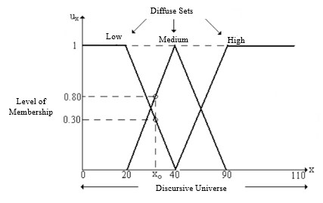

Fig. 1. Membership function and its parts

In the following paper, we model a magnetic suspension system. Said modeling is done by using a RL circuit where the input voltage, resistor and the inductor are variables that must be considered in order to generate a current across the coil of wire wrapped around an iron core and also, generate a magnetic field capable of lifting a ball. Therefore, a fuzzy controller should be implemented so the height of the floating ball can be controlled.

# Work development and analysis

## Obtaining fuzzy rules

In order to get the system to be controlled it is needed to define the equations that describe it.

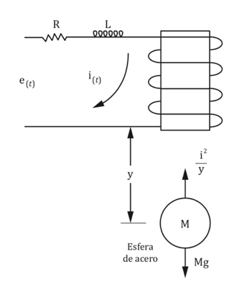

Fig. 2. Magnetic Levitation of iron sphere

These equations are below, were x1 is the distance between the ball and the magnet, x2 is the speed and x3 is the coil current

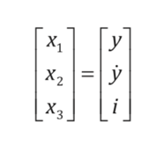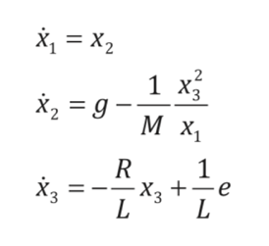

To control the system, two parameters will be considered as one input to the fuzzy controller: the distance between the iron sphere and the magnet, and the speed. In addition, the output will be the voltage applied to the magnet according to the above-mentioned parameters. This can be represented in a block diagram as shown in figure 3.

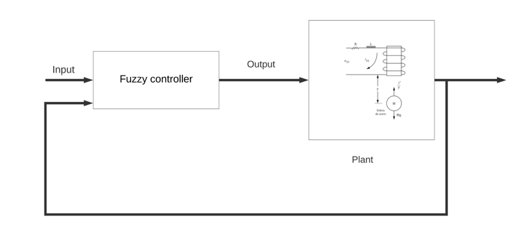

Fig. 3. Block diagram

First, for distance, the universe of discourse was taken as shown in figure 4, 7 linguistic terms were considered to describe it. This distance represents the desired distance error, that is, the difference between the current position and the reference, having as a minimum -0.02 m and 0.02 m as a maximum, being 0 the desired error.

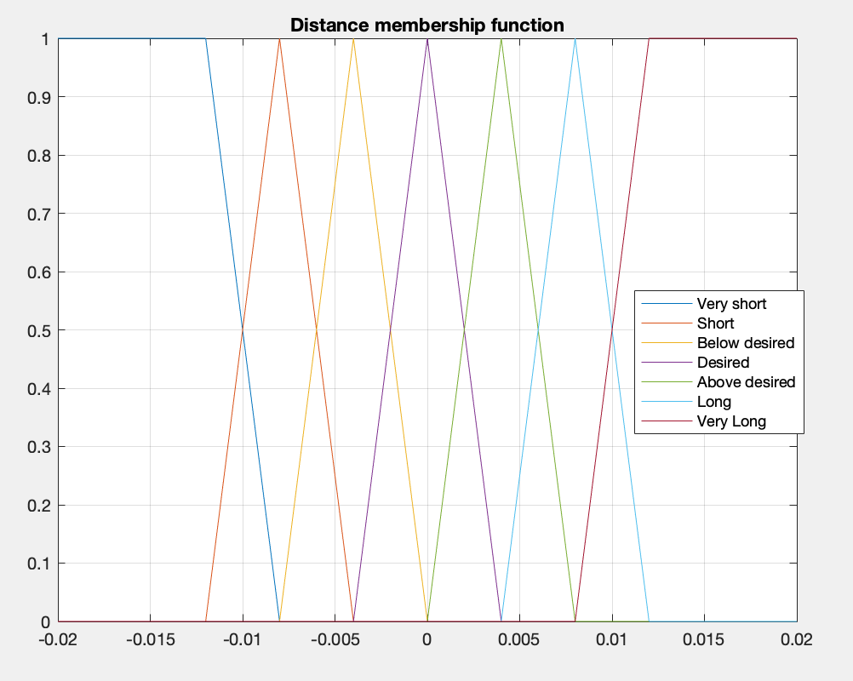

Fig. 4. Distance membership function

Then, in the speed membership function, we considered 7 linguistic terms symmetrically distributed around the zero value in the range of -0.25 m/s to 0.25m/s, because values higher than these would be too large to perform the control in this small system, besides the same precision is needed for both directions.

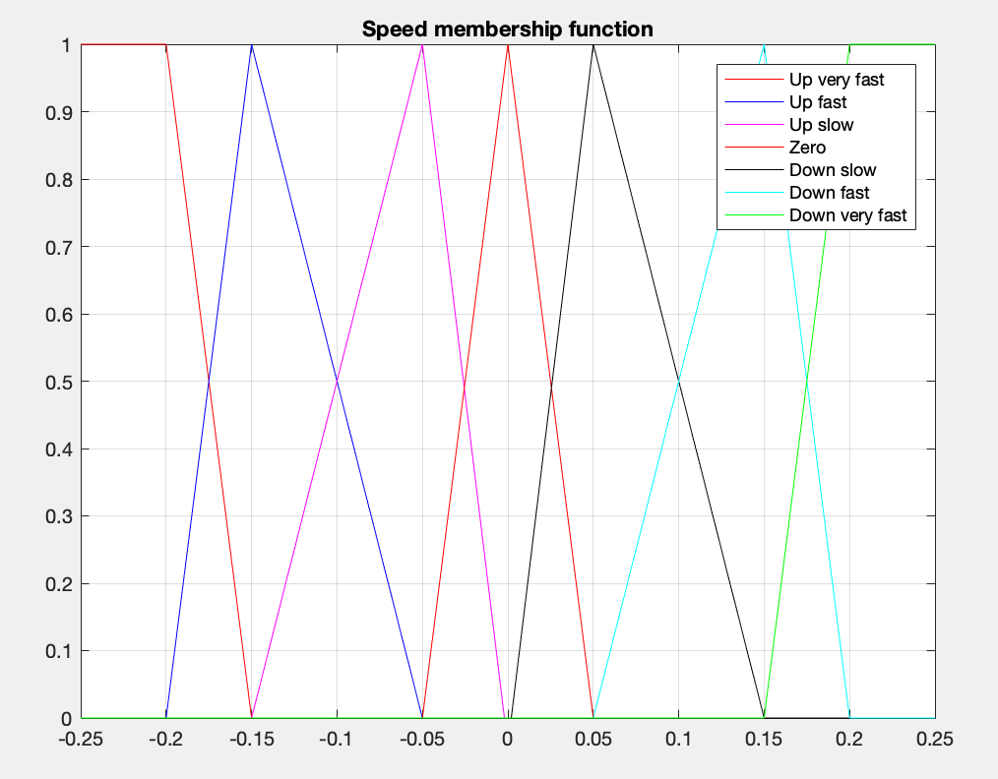

Fig. 5. Speed membership function

In the case of the voltage membership function, 7 linguistic terms were considered too, the range from 0 to 25 was considered, having as normal value 12.5, this does not represent the voltage value exactly, because these values obtained from the fuzzy controller will be converted experimentally using denormalization constants.

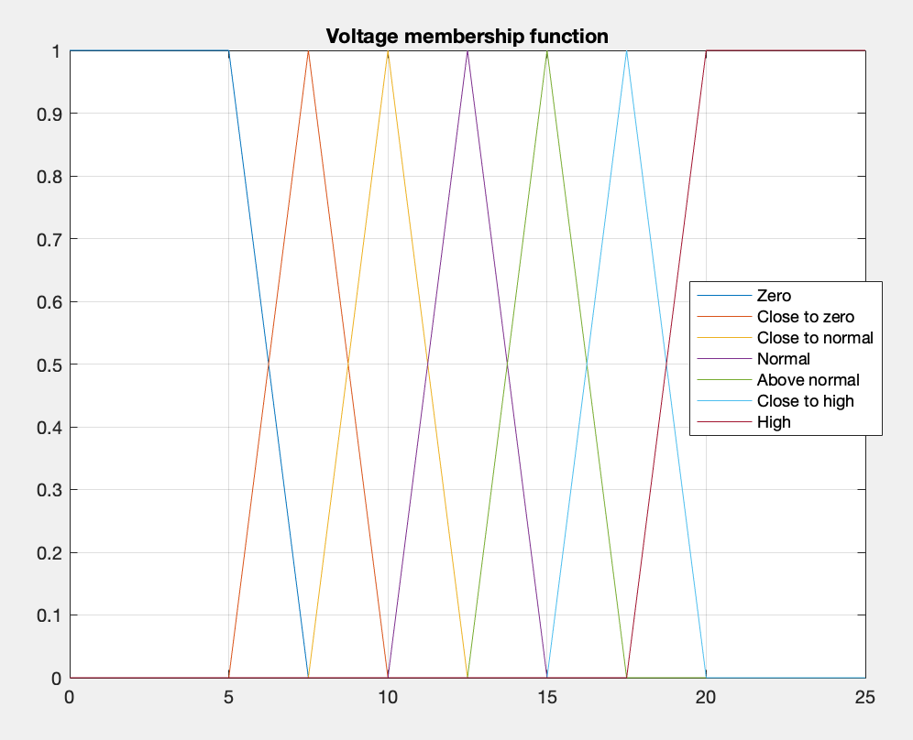

Fig. 6. Distance membership function

## FAM and Control Surface

Having the fuzzy rules, it is needed to create the Fuzzy Associative Memory to associate the linguistic terms of distance and speed with voltage. For example, if the distance between the sphere and the magnet is very short and they are getting closer, the voltage value should be as close to zero as possible.

Table 1 – First Fuzzy Associative Memory

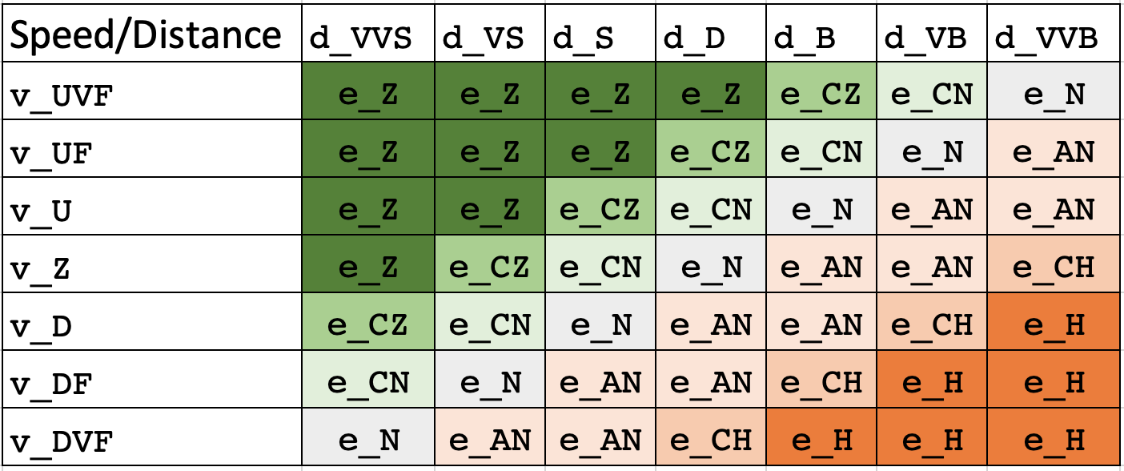

To verify if the membership functions and the fuzzy rules involved are working properly, it is a must to check the control surface so we can determine the locations of local minimums in order to avoid falling in those points.

The control surface associated with the FAM in table 1 is shown in Figure 7. As can be seen in the red circle, this control surface shows output ranges with very abrupt changes, therefore, it is necessary to modify the values included in the table to obtain outputs with a smooth change

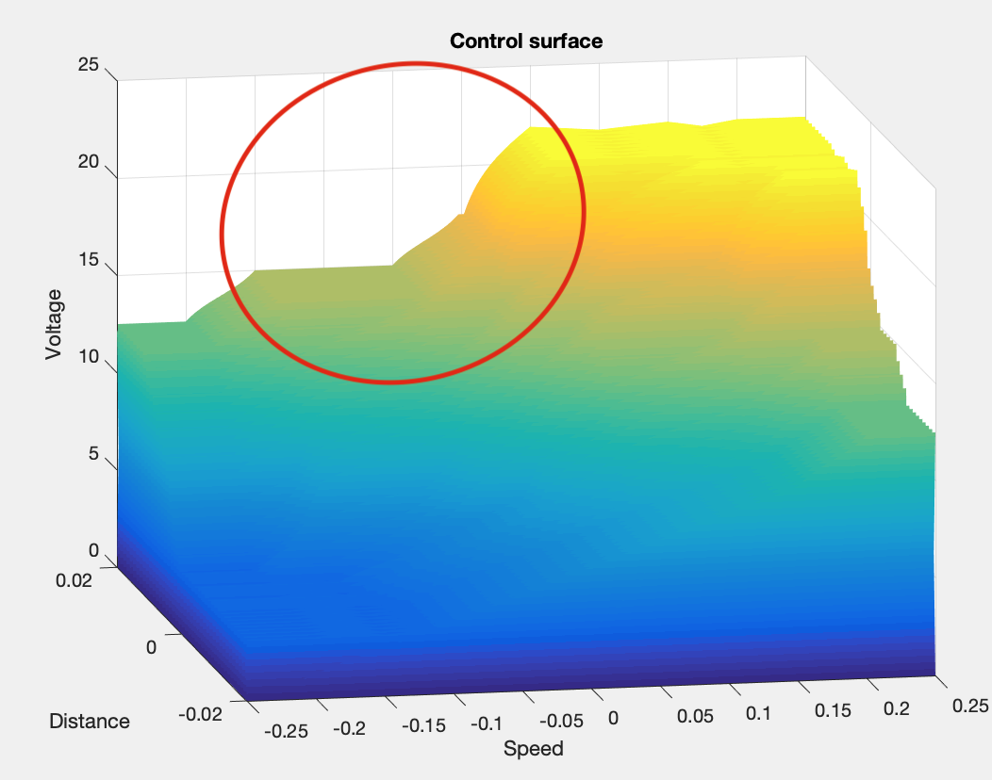

Fig. 7. First control surface of the fuzzy controller

Even if this fam successfully controls the desired system, there may be failures for certain values. After a change of values in the table, better results are obtained.

Table 2 – Best Results Fuzzy Associative Memory

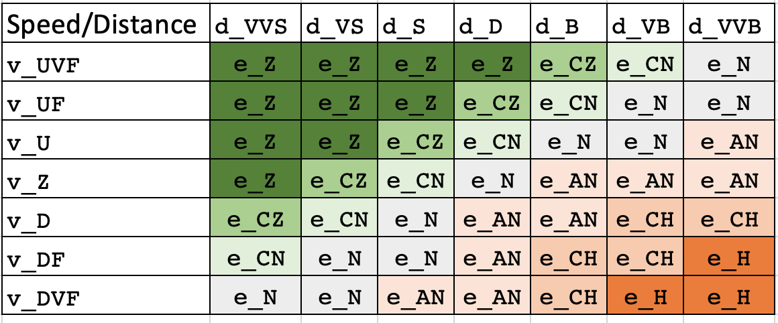

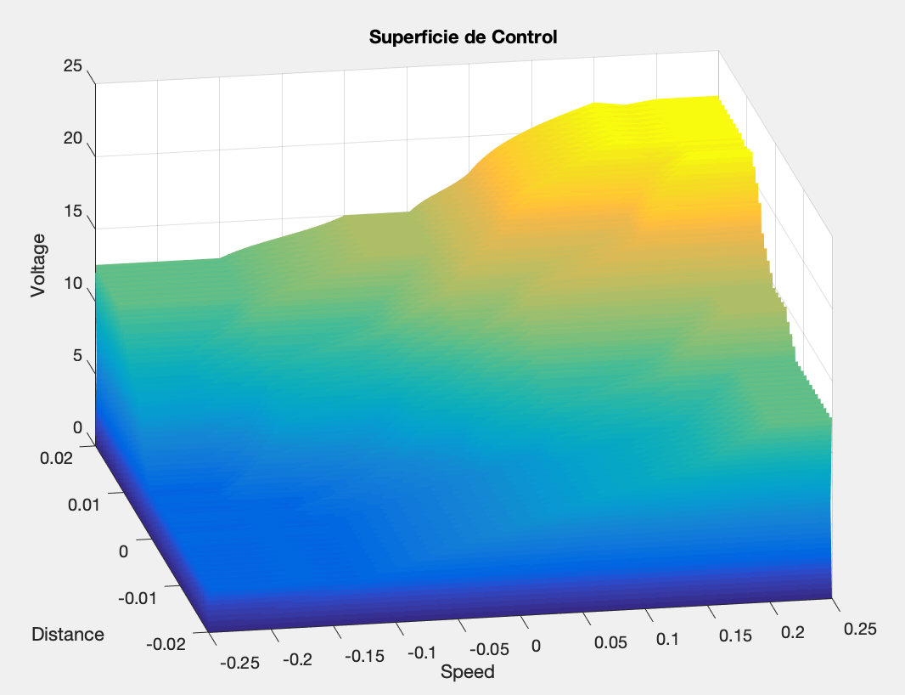

Fig. 8. Final control surface of the fuzzy controller

As we can see in figure 8, there are no local minimums and there are smoother changes, so there is no need to change the membership function or the fuzzy rules.

## Results

Once the control rules are established, the initial parameters are set to achieve control, these are: distance 0.055 m, speed 0.05 m/s and voltage 0 V and the desired position for the magnetic ball is 0.06 m. Initially there is no voltage and the speed has a positive direction, so the sphere starts to fall, that's why the distance increases, as shown in figure 9, after a small time the controller tries to return the sphere to the required value and it succeeds, the sphere remains close to the required value with small oscillations.

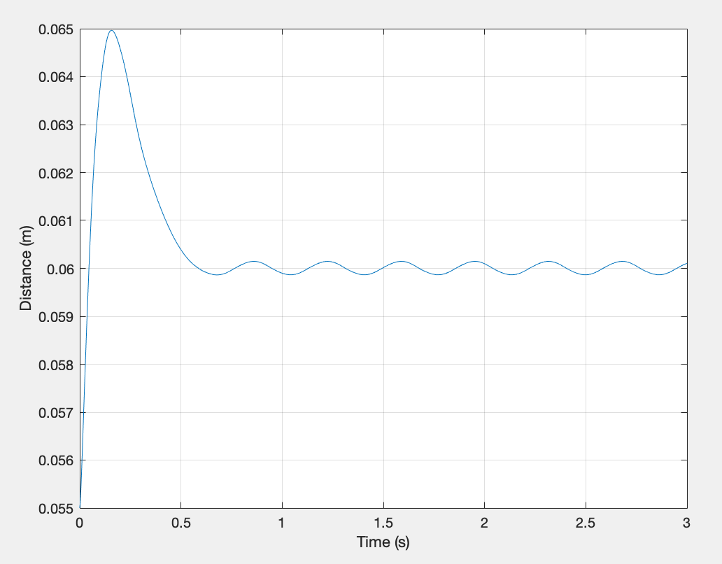

Fig. 9. Control of the distance between the iron sphere and the magnet

In figure 10 we can see the error existing between the desired distance and the sphere, when the latter begins to fall, as well as how a control around the value 0 is achieved.

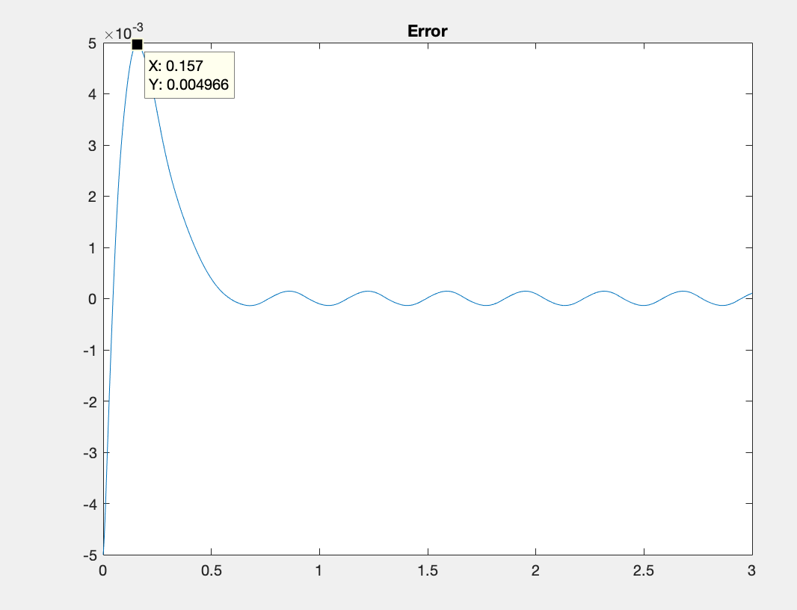

Fig. 10. Error between the current position and the established reference

# Conclusions

It is concluded, due to the work carried out, that there is no single solution, since it depends on the criteria and experience of the designers. They may know the subject on which it is to be designed or they may consult with experts, but the criteria used by each person may be different.

Regarding the control surface, when local minima appear, it is necessary to minimize or eliminate them, since, otherwise, the behavior of the controller could be affected. This can be achieved by changing the fuzzy rules and/or membership functions, as theory suggests.

The membership functions and fuzzy rules are highly dependent on the physical system being used; that is, the mass, inductance and resistance of the electromagnet must be very precise because the correct operation of the fuzzy control depends on that.

Seven linguistic variables were used, since both distance and speed, despite having very small ranges, can vary greatly and what is desired is to precisely control the fuzzy controller.

# References

1. Enrique Arnáez Braschi. *Enfoque práctico del control moderno.* Primera edición. Lima: Metrocolor S.A, 2014.
2. Lin, C. E., & Huang, W. C. (2012). Dynamic ball and plate control verification on magnetic suspension platform using enforced fuzzy logic control. International Journal of Applied Electromagnetics and Mechanics, 40(4), 259-281. https://doi.org/10.3233/jae-2012-1590
3. Luviano, David (2012) *Non-linear control of a system of magnetic levitation based on estimation of electromagnetic parameters*. <https://www.ctrl.cinvestav.mx/~yuw/pdf/MaTesDLC.pdf>

# Annex